Name:___Loz # 6__________________

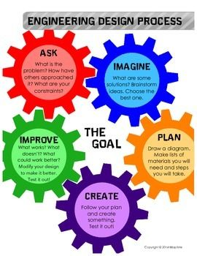

**Catapult Design Challenge**

**What is the challenge?**

To design a catapult that will move materials from one place to another.

**Possible Materials:**

* Large and small craft sticks
* Rubber bands or hair elastics
* Binder clips
* Plastic spoon
* Plastic cup
* Clothespin
* Scissors
* Ruler
* Ask Mrs. Kenney if you need help substituting materials

**Imagine and Plan: (6 points)**

1. How could you build it? I could build a catapult by using the spoon as the launcher and the binder clips as the weight. The ruler will measure how far it goes. The rubber bands will support the whole thing from falling down. The plastic knife will be at the bottom.
2. What materials are you using? The materials I will be using are a ruler, rubber bands, a plastic spoon, a plastic knife, and binder clips.
3. What does a catapult do? A catapult launches things in the air and goes far or a short distance.
4. How does a catapult work? The catapult works by the use of stored energy to hurl a projectile.
5. What type of simple machine is it? How do you know? A catapult is a type of lever. I know this because a lever can lift something heavy or make it go fast.

**Create: Build your catapult (2 points)**

1. Build your catapult and take a picture of it. 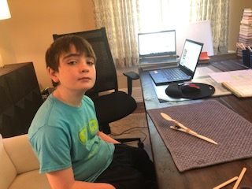

**Test: (4 points)**

1. What items are you launching? I am launching pennies.
2. How far can you launch objects? I can launch objects about 44 inches average.

**Evaluate: (4 points)**

1. What worked well in your design? Give at least three specific things and tell me how or why each thing worked well. For example, do not not say binder clips worked well, instead explain how you used binder clips to make them work well. Please be detailed. The first material that was great was the binder clips. The binder clips were behind the spoon for weight so I could launch stuff and the spoon would have weight from the binder clips. The second material that was great was the rubber bands. The rubber bands were great because they held the whole thing from falling apart. The final material that was great was the plastic spoon. The plastic spoon was great because it made everything nice in place so nothing fell down.
2. What could you do to improve your design? To improve my design I could add more materials and make more weight.

**Reflect: (4 points)**

1. What one material do you think made the biggest difference in creating a successful catapult? Explain why you chose that one. I think the binder clips made a big difference in creating a successful catapult because they were the weight and without the weight there would be no launcher or catapult.
2. What forces were used to move the projectile- pushes or pulls? Explain your answer by giving examples using your catapult design. A catapult uses stored energy by pressing down on the spoon and releasing it. The object that is hurled into the air from the catapult uses gravity.
3. What happens to the projectile if no force is applied? Why? If a projectile had no force then you couldn’t launch it because the force makes the object fly but without it wouldn’t.
4. What would you do differently next time and why? Next time I would make it taller and build it more sturdy.